**Computer Human Interaction**

**With some Fundamentals of UX design**

Contents

Introduction: 2

Technical proficiency: 2

User friendliness: 3

Jakob Nielsen’s Usability Heuristics 4

# Introduction:

In this assignment, I had developed a website tackling the food industry. The hotel “Food Factory” has given us the task to create a customized website for them. The name of our website will be the same as the name of the hotel “Food Factory”.

On the main page of the website, we have a brief description of our hotel summarizing the heritage, specialties, location of our hotel and contact information direct link. Our hotel takes great pride in the staff that we hire and we have also displayed our chef and the variety of exquisite cuisines that they offer. After that, we had shown our menu in which each dish has a detailed description of its origin and ingredients. Each dish has also had a picture of the price.

We have adopted a compact factor for the website presenting all the information that is important right in front of the user. We believe to go all out and overwhelm and impress our customers with a short and brief view of our hotel. So we developed a website with multiple pages and we focused to give the viewers all the necessary information that they need to know and impress them at the same time.

At the last page, we had provided the hotel’s address, contact details and social media details such as Facebook, twitter and google. It is very crucial for us to know what the customer thinks about us so we had provided a suggestion box so we get to know what the customers need from us.

# Technical proficiency:

This website is created by using HTML, CSS, JavaScript, Jquery, and Php. I followed the standard format while creating this website. Index page shows all over the summary of the business. Once a customer sees the index page he/she gets an idea about the business, website, and items. It also has an attractive font and eye-catchy color combination which helps to engage the customers to the site. Breadcrumbs are available on every page to navigate the customer. I used images with good quality with less size that help me to load website in minimum time.

On our website, the home page includes a standard navigation bar with a logo of the hotel, contact information at top, search option, login form, slider with good quality images to attract user attention, brief information about the hotel, Specialty items with short descriptions, Testimonials given by clients, and contact details with google map. It also provided social media at the left corner.

About us, the page contains hotel information also the uniqueness of the hotel. The menu page is the next page of the website which contains all information about items also provided buy options in that. For this, I used vertical menu bar to show the menu of the items. There is a confirm order button is available which takes you to the payment page.

The chef page contains photos in a circular shape, name and social media links of the chef. The gallery page shows a variety of dishes with zoom in-zoom out options. Contact us page provides all contact details also has a suggestion box in that the user can send a suggestion for the hotel also has a google map to find the hotel easily for customers.

At last, the order page, On click of this page user will see all menu items they can add items into the cart then there is a confirm order button on click on the user will go on payment option for payment option there is payment gateway is added. So that people can make the payment.

# User friendliness:

Our website is highly flexible. Loading time is less; color combination follows the standard format proper contrast which text and background color. The website is responsive; user can run in any size of the screen. The connectivity of all pages is quick and perfect. On the home page you can see at top of the website there is a search option so that users can search for items directly from there. Moreover, contact details are provided at the top so that the user can easily contact the hotel.

Social media is provided to all the pages, customer can go through that to check the reviews and comments of the hotel.

The testimonial section is there to know more experience with other customers. The top-up bar is there to at bottom to go directly up without scrolling.

The menu page is an extra interactive page in that the user can see all items on clicking the left corner bar then there is quantity add an option so that the user can increase the quantity and add to the cart.

On click of confirm order button user can view the payment option.

The payment option gives you some blocks to fulfill which is important to make payment. This is a really easy, comfortable and secure website for the customer.

# Jakob Nielsen’s Usability Heuristics

* **Visibility of System status**

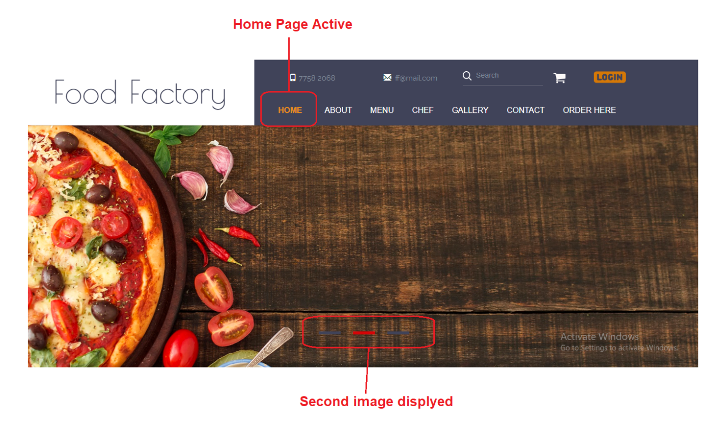

Fig. 1(a) Visibility

In fig.1(a), the active page name is highlighted, customers can see the On which page there are currently. Also at the bottom, those buttons show three things which are there is the slider, the second thing which image is currently showing and how many images are available in a slider.

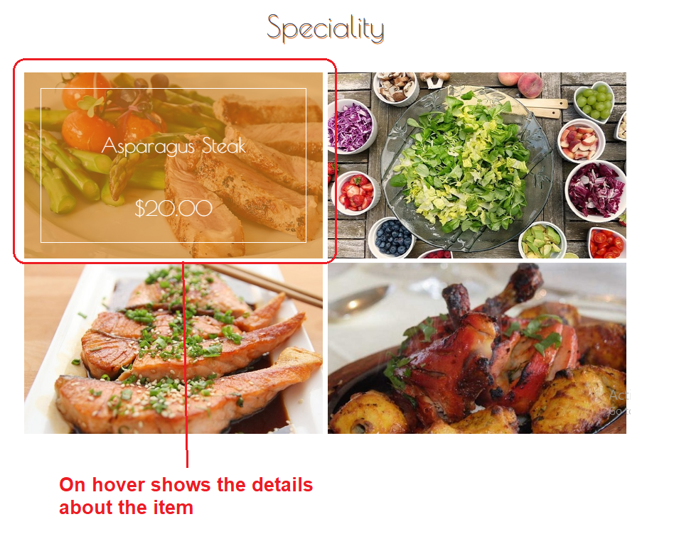

Fig. 1(b)

Fig. 1(b), shows brief details about the specialty menu.

* **Match between system and the real world**

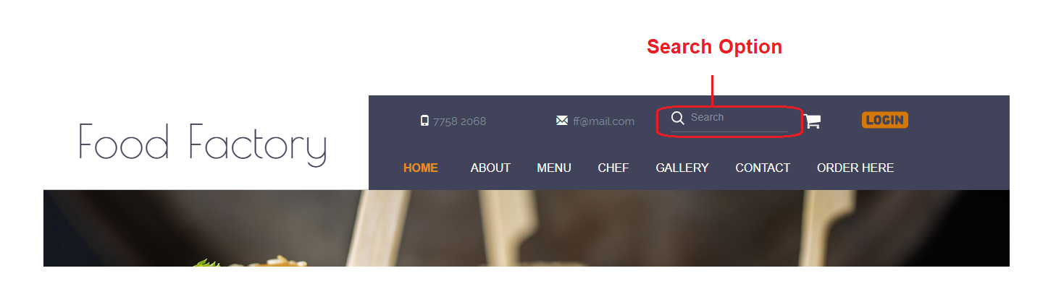

Fig. 2(a) Match with real world

In this fig.2 (a) 'Search', the option is shown which is matched with the real world. Customers can search the items directly through this option.

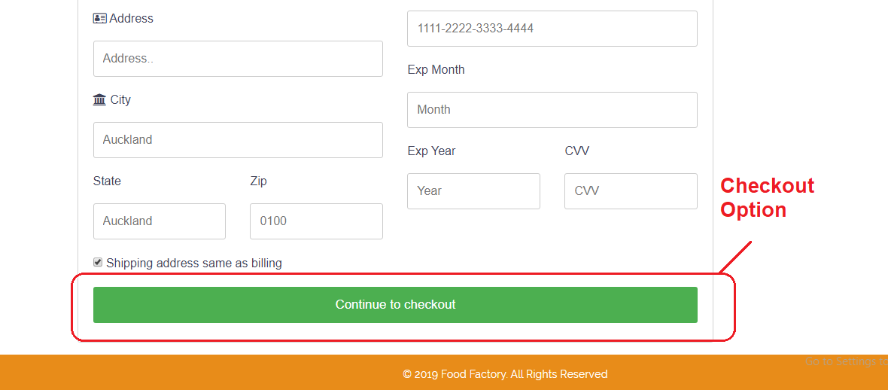

Fig. 2(b) Match with real world

Fig. 2(b) shows the checkout option. On click of this customer can directly connect to payment gateway.

* **User control and freedom**

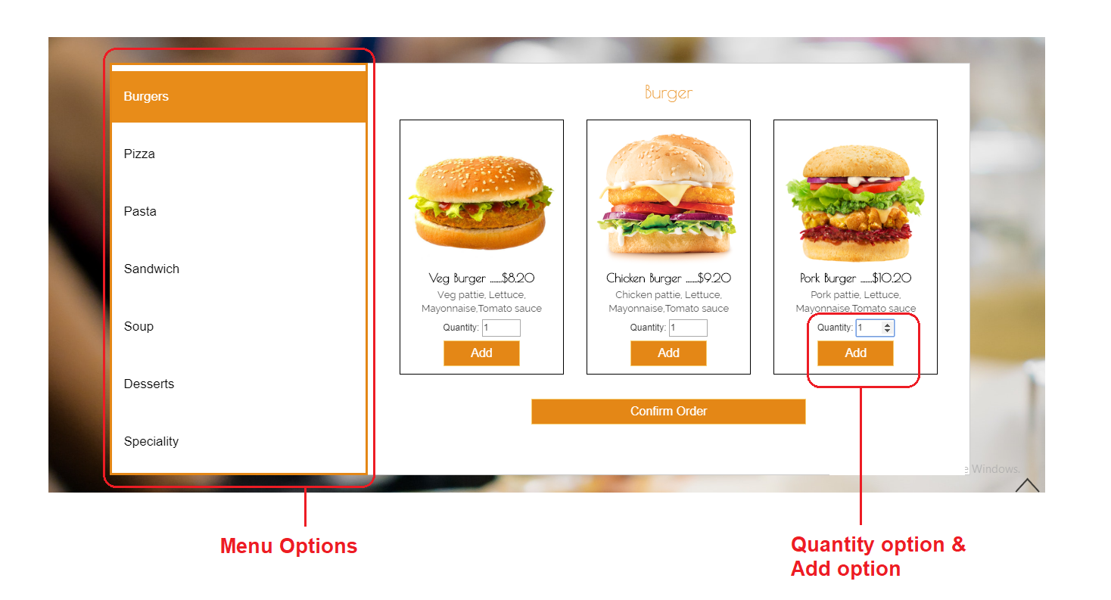

Fig. 3 User Control

In this fig. 3 Customers can select the main option from left options then there is quantity option to enter their item quantity then add the button to add into a cart.

* **Consistency and standards**

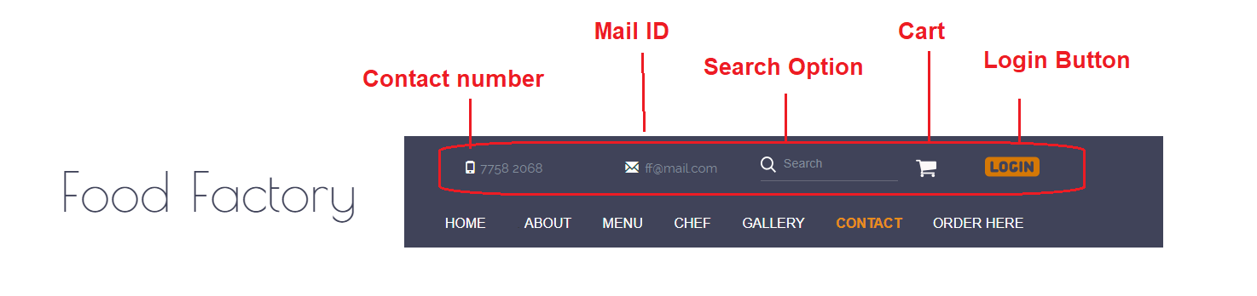

Fig. 4 Consistency and standard

In fig. 4 you can see there is a standard format that is used to show contact info. Appropriate icons are used to show phone, mail id, search, address, cart, and log in.

* **Error Prevention**

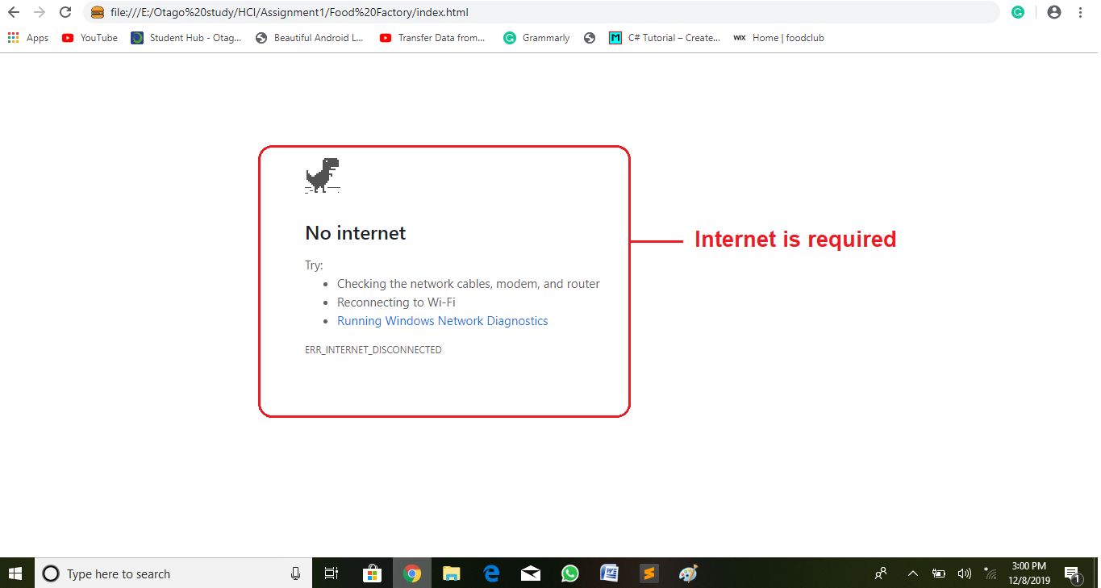

Fig. 5 Error Prevention

This fig. 5 gives the error message so that user can read it and easily prevent that quickly.

* **Recognition rather than recall**

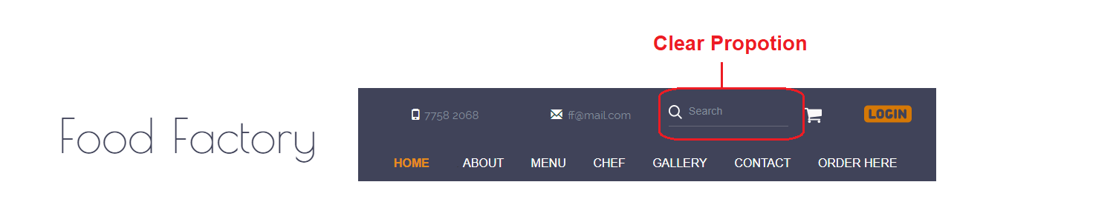

Fig. 6 Recognition rather than recall

In this fig. 6 customer can directly find the item using this option.

* **Flexibility and efficiency of use**

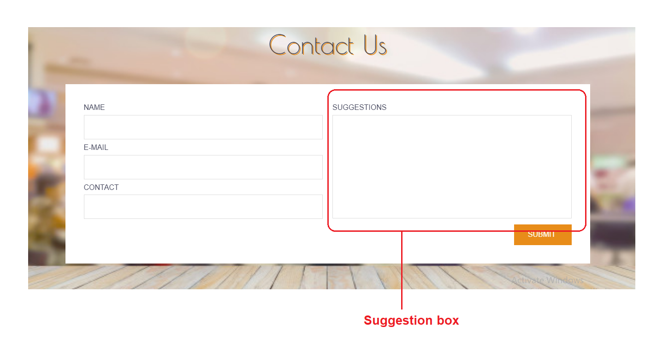

Fig. 7 Flexibility and efficiency of use

In above fig. 7 customer can provide direct feedback to the owner of the website. Also in fig.3 user can place order by choosing the given menu options.

* **Aesthetic and minimalist design**

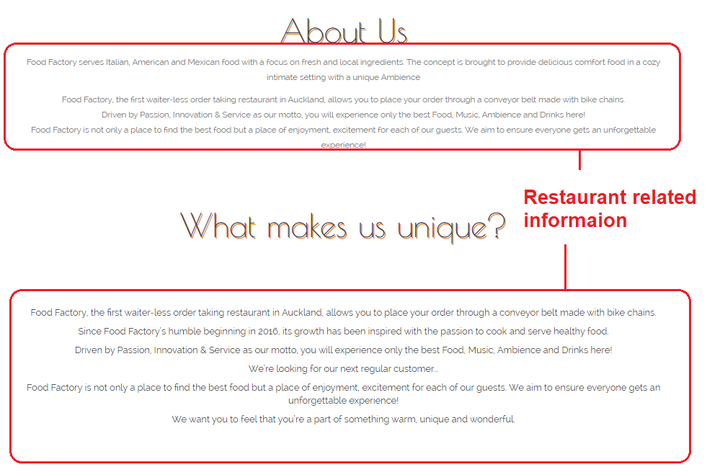

Fig. 8 Aesthetic and minimalist design

In fig. 8 you can see we added proper content related to the hotel. Customer can know more about the hotel.

* **Help users recognize, diagnose, and recover from errors**

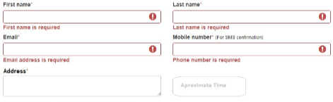

Fig. 9 Recover from error

Fig. 9 shows the error message so that user can solve that error easily.

* **Help and documentation**

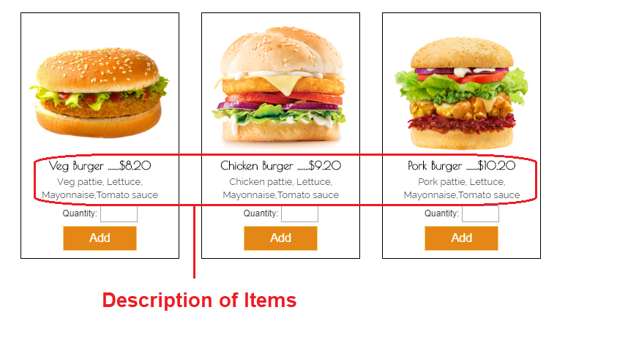

Fig. 10 Help and documentation

In the above fig. 10 users can see all descriptions about the item it will get easy to the customer to choose items.